NEW TRINITY BAROQUE WORKSHOP
with MARION VERBRUGGEN – RECORDER (The Netherlands)
and members of NEW TRINITY BAROQUE:
Predrag Gosta – harpsichord, Adriane Post – violin, William Bauer – viola, André O’Neil – cello

SUNDAY, APRIL 27, 2008, FROM 3 PM to 7 PM
At Rock Spring Presbyterian Church, 1824 Piedmont Ave NE, Atlanta, GA 30324

Presented by New Trinity Baroque (NTB),
in collaboration with the Atlanta Early Music Alliance (AEMA) and the Atlanta Recorder Society (ARS)

Registration Form

Name: ____________________________________________________________________________________

Address: __________________________________________________________________________________

Phone: __________________________ Email: __________________________________________________

I AM APPLYING TO ATTEND THE WORKSHOP IN (PLEASE DESIGNATE):

 Recorder  Violin  Viola  Cello  Harpsichord
(with M. Verbruggen) (with Adriane Post) (with William Bauer) (with Andre O’Neil) (with P. Gosta)

PLEASE INDICATE YOUR SKILL LEVEL / PROFICIENCY:

 beginner  capable / moderate  advanced  professional

RECORDER PLAYERS (440 Hz), WHAT INSTRUMENT(S) WILL YOU PLAY?

 Soprano  Alto  Tenor  Bass  Other: _____________________________

Payment:

Please mail this completed form with your payment, to:

NEW TRINITY BAROQUE INC.
2479 Peachtree Rd NE #101
Atlanta, GA 30305

Alternatively, you can register and pay securely online at www.newtrinitybaroque.org

 I enclose my check for  $45 (AEMA, ARS, Friend of NTB, student) OR  $60 (Payable to NTB)

 Please charge  $45 or  $60 to my:  MC  Visa  AmEx  Discover

Card number: ______________________________________________________ Expiration: ______________

Name on card: _____________________________________________________ CVV Code: ______________
Additional Information

Faculty members’ biographies are available at NTB’s website, at www.newtrinitybaroque.org.

Date and Time: The workshop will be from 3PM to 7PM on Sunday, April 27, 2008. We plan to begin the session promptly at 3PM – please try to arrive early to allow time for setup, etc.
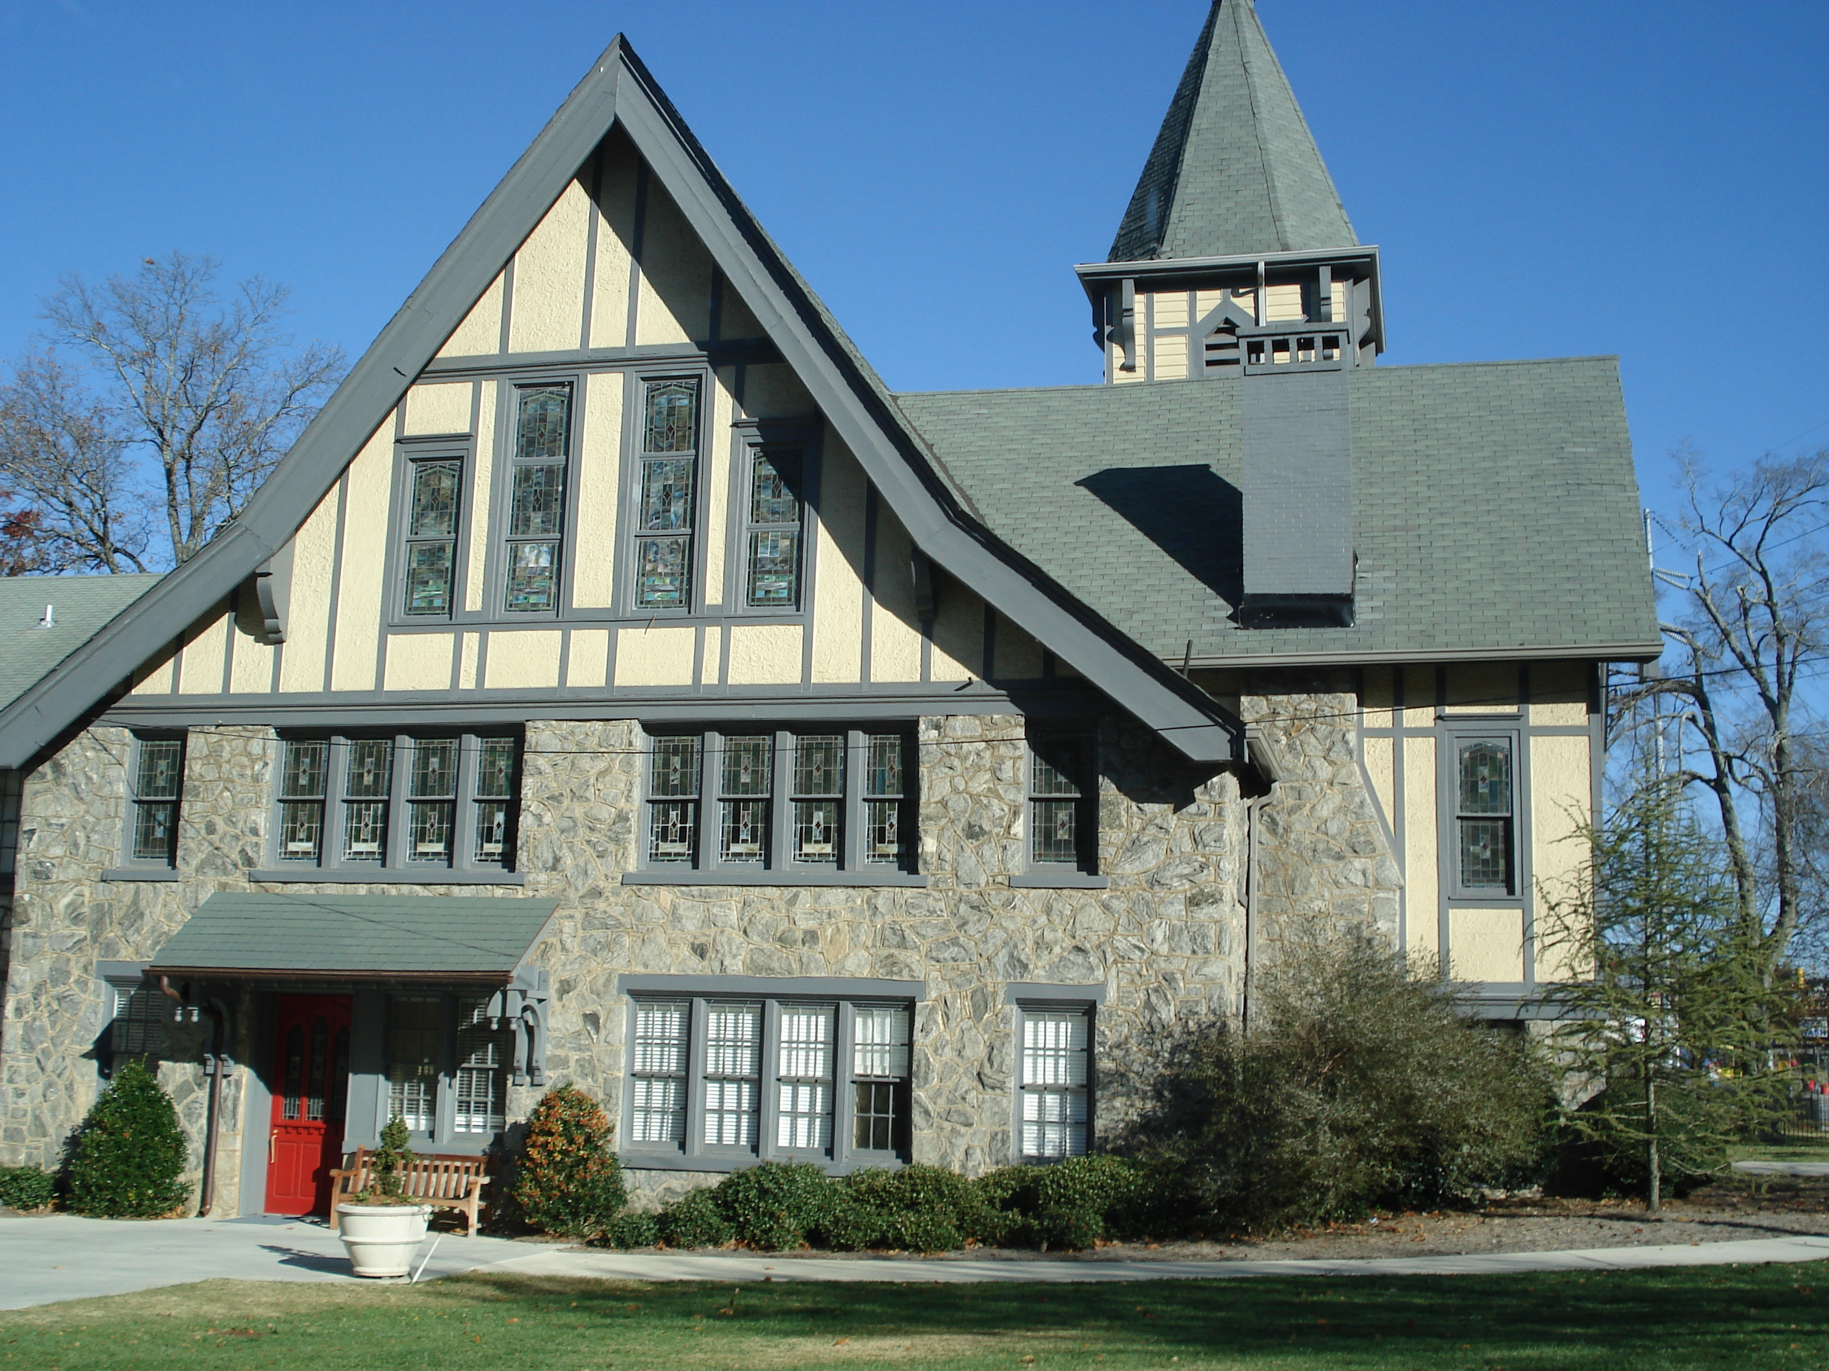
3PM to 5 PM First Session
5PM to 7PM Second Session

(it is permissible to attend only one of these two sessions)

Location: Rock Spring Presbyterian Church, in Midtown. The Address is 1824 Piedmont Ave NE, Atlanta, GA 30324. The Church is located on Piedmont Avenue, approx. 2 miles south from Lindbergh MARTA station. For directions, please check the church’s website, www.rspc.org

Cost: For members of AEMA, the Atlanta Recorder Society (ARS), Friends of NTB and full-time students, the cost is discounted to $45. All others: $60.

………………………………………………………………………………………………………………………

Music: The music will be provided for you and is included in the fee. The program will include consort music.

Music Stands: Church has a limited number of music stands. Please bring your own stand if you have one.

Pitch: The pitch for this workshop will be 440 Hz.

Age Limit: Players age 14 and above and of all proficiency levels are encouraged to attend.

Enrollment/Registration: The enrollment is limited and will be accepted on a “first come – first served” basis. Since we expect big interest, we encourage you to submit your registration as soon as possible. You will be notified by email or phone once your application has been processed (2-3 days).

